

Anyscale Overview
The Product
The Problem
Userbase
Company Facts
Funding
Leadership
Additional Information
Frequently Asked Questions (FAQs)
Careers @ Anyscale

The Product
Anyscale provides a development platform intended to simplify distributed computing which enables software developers of all skill levels to build applications that run at any scale from a laptop to a data center.

We're commercializing a popular open source project called Ray - which is an “operating system” for heterogeneous distributed computing as well as an ecosystem of libraries for scalable machine learning, including large language models (LLMs) and GenAI.

Our goal is to enable organizations to accelerate the progress of AI applications out into the real-world and at lower cost.

The Problem
The trend that we are seeing is that Machine Learning is becoming absolutely essential for almost all applications being built nowadays.

The demands of applications utilizing Machine Learning are growing faster than ever, but Machine Learning still remains extremely difficult to program at scale.

There are two ways to expand capacity to execute any task (within and outside of computing): a) improve the capability of the individual agents that perform the task, or b) increase the number of agents that execute the task. While the former pushes the technological limits of how well our agents are built to do the task, the latter
approach requires sophisticated coordination between agents (distributed computing) to execute tasks.

The solution to this problem is to build applications while utilizing distributed computing, but distributed systems are also extremely difficult to build and manage.

So the question is then how do you make distributed computing accessible?

This is what Anyscale aims to accomplish.

Userbase
- Software engineers and developers
  - Engineering teams at small & medium-sized enterprises (SME) & enterprise organizations
  - Individual engineers
- How Ray is being used as the compute substrate of ML platforms
  - Ray Summit 2023
    - Day 1 - Announcement of Anyscale Endpoints is at the beginning, and also includes our CEO Robert Nishihara interviewing John Schulman, co-creator of OpenAI, really fun to hear that conversation!
    - Day 2 - Includes folks from Uber, Niantic, and Adobe sharing how they are using Ray, and Robert interviewing Ben Horowitz of a16z, a crowd-favorite conversation.
    - Our press release was picked up here, and the NVIDIA blog post is helpful to understand how we are partnering with NVIDIA to "supercharge LLM performance and efficiency to deliver cost savings."

Company Facts
- Location: 55 Hawthorne St. San Francisco, CA
- Company size: 125 total
- We recently announced our Series C and general availability! See more here.

Funding
Anyscale has raised about $259M in three rounds:
- December 2019: $20M Series A led by Andreessen Horowitz (a16z), with participation from New Enterprise Associates (NEA), Intel Capital, Ant Financial, and more.
- October 2020: $40M Series B led by NEA, with participation from a16z, Intel Capital, and Foundation Capital, and more.
- December 2021: $100M Series C led by a16z and Addition, with participation from NEA, Intel Capital, and Foundation Capital.
  - Additional $99M Led by a16z announced during Ray Summit 2022

Leadership
Ray was developed at UC Berkeley by Robert Nishihara and Philipp Moritz, under the guidance of Ion Stoica. The three of them have co-founded Anyscale, a company to support the development and commercialization of Ray.
- Co-founder: Robert Nishihara
  - Co-creator of Ray
- Co-founder: Philipp Moritz
  - Co-creator of Ray
- Co-founder: Ion Stoica
  - Co-founder and former CEO of Databricks (recently valued at $38 billion)
- Chief Architect: Sriram Sankar
  - Formerly, Uber Eng Lead, Software Engineer @ Meta
  - Read about his decision to join Anyscale here
- Head of Engineering: Jaikumar Ganesh
  - Read about his decision to join Anyscale here

Office

- Return to office 3x per week(Mon/Tue/Thu) out of the SF Headquarters(55 Hawthorne St.)
- Weekly Thursday In-Office Happy Hours 🍻

Additional Information
- Anyscale Product Demo

2024
- Anyscale Teams Up With NVIDIA to Scale Generative AI Models Into Production
- The Anyscale Platform
- Scaling AI and Python Workloads Effortlessly with Ray
- Making AI Infrastructure Headaches Disappear in 2024

2023
- How Ray, a Distributed AI Framework, Helps Power ChatGPT
- Unleashing ML Innovation at Spotify with Ray
- Building an LLM open source search engine in 100 lines using LangChain and Ray
- Why I Joined Anyscale: Solving Cutting-Edge Problems in a Time of Enormous Change

2022
- AI Startup Anyscale Adds $99 Million to Andreessen Horowitz-Led Funding Round
- Ray, the machine learning tech behind OpenAI, levels up to Ray 2.0
- Microsoft and ByteDance are collaborating on a big AI project, even as US-China rivalry heats up
- ChatGPT got all the buzz, but beneath it is a $1B developer framework that's quietly fueling the new era of lifelike AI at OpenAI and beyond

2019 - 2021
- Berkeley Research Lab Group Mints Second Billion-Dollar Business In Startup Anyscale
- Ben Horowitz - Why We’re Investing in Anyscale
- The Future of Computing is Distributed
  - Video: https://www.youtube.com/watch?v=dl29iiRIBT8
- Ray for the Curious
- Understanding the Ray Ecosystem and Community
- Videos and Slides for the First Ray Summit Connect
- Anyscale Academy: Ray Crash Course Tutorial, May 2020

Social Media
- Anyscale Website
- Twitter (Anyscale, Ray)
- LinkedIn (Anyscale, Ray)
- Anyscale YouTube
- Anyscale Facebook
- Blog (Anyscale, Ray)

Frequently Asked Questions (FAQ)
- What is the premise behind Ray (open-source project)?
We are sitting at the intersection of four major trends: continued rise of artificial intelligence (AI), rise of distributed applications, proliferation of python, and increasing demand for serverless computing.

Distributed applications will soon become the norm, rather than the exception. There are two major trends fueling this transformation: the end of Moore’s Law and the exploding computational demands of new applications, especially in machine learning. These trends are leading to a rapidly growing gap between application demands and single-node performance which leaves us with no choice but to distribute these applications. Distributed systems are difficult to build and maintain. Ray was created to solve this problem.

As machine learning algorithms and techniques have advanced, more and more machine learning applications require multiple machines and must exploit parallelism. However, the infrastructure for doing machine learning on clusters remains ad-hoc. While good solutions for specific use cases (e.g., parameter servers or hyperparameter search) and high-quality distributed systems outside of AI do exist (e.g., Hadoop or Spark), practitioners developing algorithms at the frontier often build their own systems infrastructure from scratch. This amounts to a lot of redundant effort.

As an example, take a conceptually simple algorithm like Evolution Strategies for reinforcement learning. The algorithm is about a dozen lines of pseudocode, and its Python implementation doesn’t take much more than that. However, running the algorithm efficiently on a larger machine or cluster requires significantly more software engineering. The authors’ implementation involves thousands of lines of code and must define communication protocols, message serialization and deserialization strategies, and various data handling strategies.

One of Ray’s goals is to enable practitioners to turn a prototype algorithm that runs on a laptop into a high-performance distributed application that runs efficiently on a cluster (or on a single multi-core machine) with only a few additional lines of code. Such a framework should include the performance benefits of a hand-optimized system without requiring the user to reason about scheduling, data transfers, and machine failures.

- What is Ray?
Ray is an open-source framework (an “operating system”) for developing distributed applications and libraries on heterogeneous clusters.

It consists of two key layers:
- A general purpose core (Ray core): enabling users to build distributed applications as easy as building these applications on their individual laptop.
- A set of libraries, such as machine learning and reinforcement learning libraries (i.e., RaySGD, Tune, RLlib, Ray Serve): this enables domain capable users to solve machine learning and reinforcement learning problems at any scale.
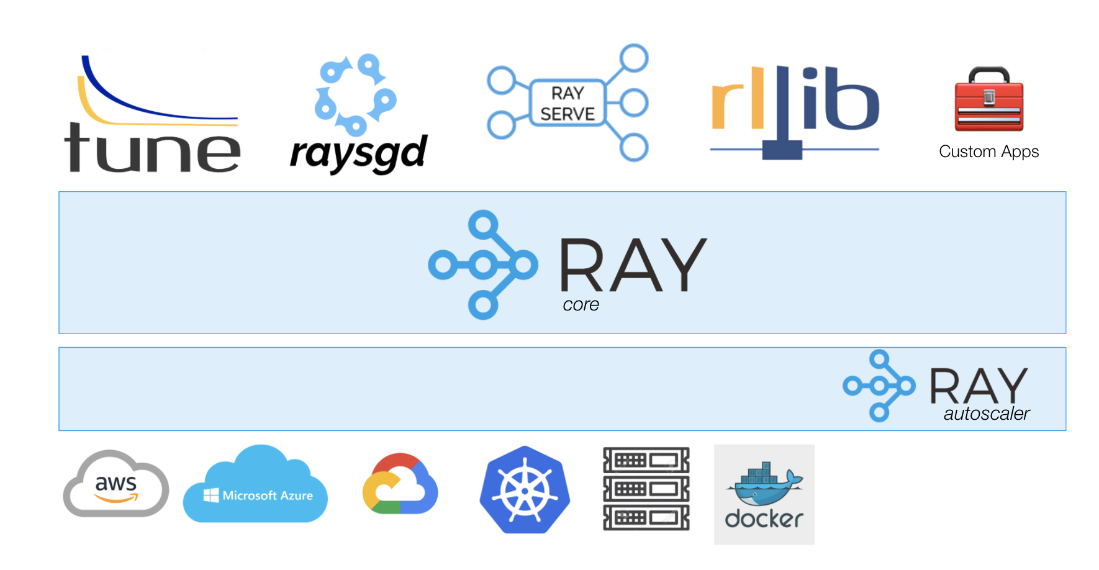
The design of Ray is driven by the unique needs of next-generation ML/AI systems, which face several unique challenges, including diverse computational patterns, management of distributed, evolving state, and the desire to address all those needs with minimal programming effort.

Typical ML/AI systems require diverse computational patterns to support data cleaning and preparation, hyperparameter tuning, model training and serving, and other chores. The original MapReduce model for big data workloads works well for data cleaning, preparation, and also for analysis workloads, but machine learning workloads require a mixture of fine-grained to coarse-grained tasks, along with varied communication patterns between components. Hyperparameter tuning and model training are very compute-intensive, requiring cluster resources to complete in reasonable time frames. Ray provides the foundation for building modern ML/AI systems and applications by satisfying these diverse requirements in a performant manner, with a minimal and intuitive API.

A second challenge is the distributed, evolving state. In the context of ML/AI, distributed state includes the hyperparameters, model parameters (e.g., and for reinforcement learning scenarios, the state of simulations (or interactions with the real world) used for training. Often the state is mutable, especially during training, so careful, concurrency-safe updates are required. One possible way of handling distributed computing is to exploit popular “serverless” systems, but none currently offers facilities for managing distributed, mutable state. Developers must resort to keeping all state in a database when using serveless systems, but the database can be a bottleneck and a single point of failure.

Instead, Ray uses the popular Actor model to provide an intuitive mechanism for state management. Ray actors provide a stateful complement to Ray tasks, which are stateless. This state is transparently reachable to any other Ray actor or task through a reference to the corresponding Python object (i.e., an instance of a Python class). Ray keeps track of where the actor is located in the cluster, eliminating the need to explicitly know and manage such locations in user code. Mutation of state in the actor is handled in a thread-safe way, without the need for explicit concurrency primitives. Hence, Ray provides intuitive, distributed state management for applications, which means that Ray can be an excellent platform for implementing stateful serverless applications, in general. Furthermore, when communicating between actors or tasks on the same machine, the state is transparently managed through shared memory, with zero-copy serialization between the actors and tasks, for optimal performance.

Finally, because most ML/AI systems are Python-based, developers need a way to add these scale-out capabilities with minimal code changes. A decorator, @ray.remote, marks functions and classes as logical units that can be instantiated and executed in a cluster. Ray transparently handles thread-safe mutation of state, distribution of state, and intuitive scheduling of dependent tasks.

The Ray distribution includes several high-performance libraries targeting AI applications, which were also motivating problems that drove the creation of Ray. They include Tune for scalable hyperparameter tuning, RLlib for scalable reinforcement learning, RaySGD for distributed training wrappers, and Ray Serve for scalable and programmable serving. All of these libraries demonstrate Ray’s unique capabilities. These libraries and other, custom applications written with Ray are already used in many production deployments.

- Where is Ray currently being used?
Ray is an open source project started in the UC Berkeley RISELab in 2016. It is now developed at Anyscale with major contributions from many other organizations. Commercial users of Ray include Ant Financial, JP Morgan, Intel, Microsoft, Ericsson, Skymind, Primer, and many others. We have a flourishing open source community with over 300 contributors. See below for some examples of implementations.

- Microsoft (using RLlib & Ray Tune to run their entire RL stack on Azure Machine Learning)
- Amazon (using RLlib & Ray Tune to run their entire RL stack on Amazon SageMaker RL)

Ray Open-Source Adoption Since Launch (comparison with other successful open-source projects)

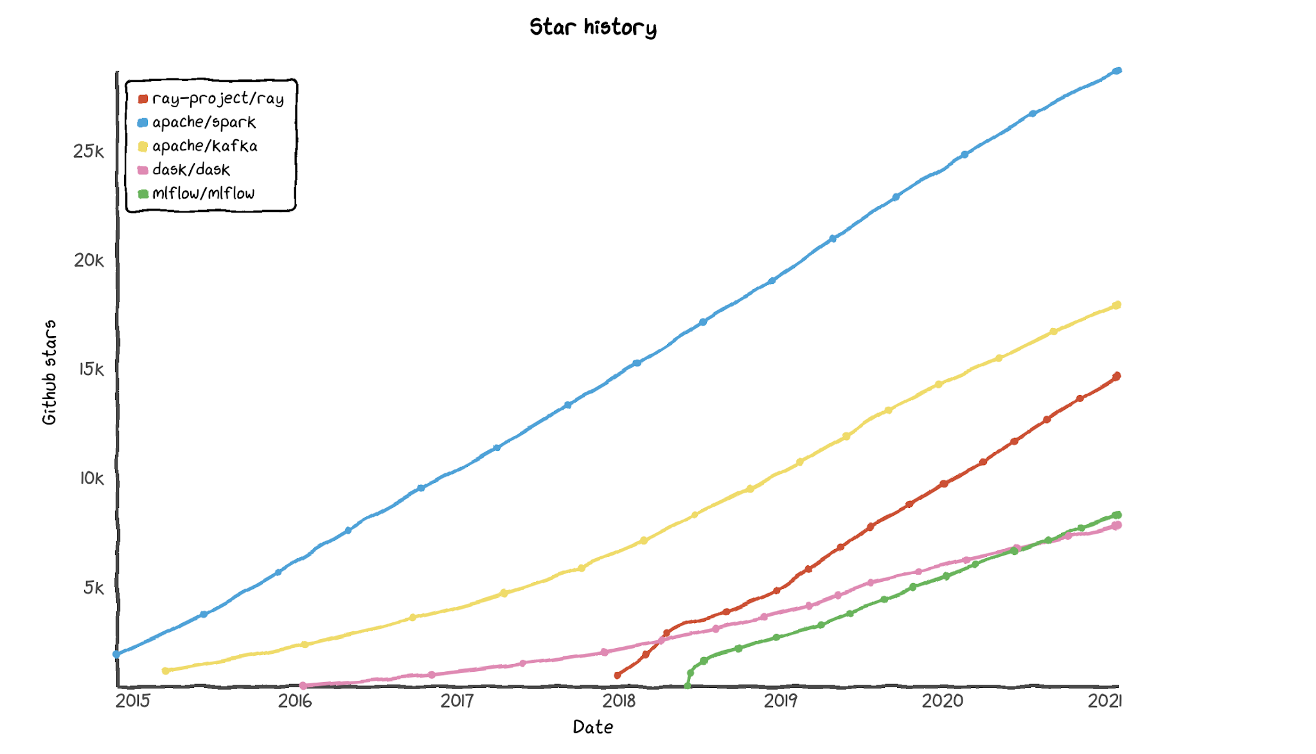

- What is Anyscale?
Anyscale was founded by the creators of Ray. Anyscale is a unified compute platform that makes it easy to develop, deploy, and manage scalable AI and Python applications using Ray.

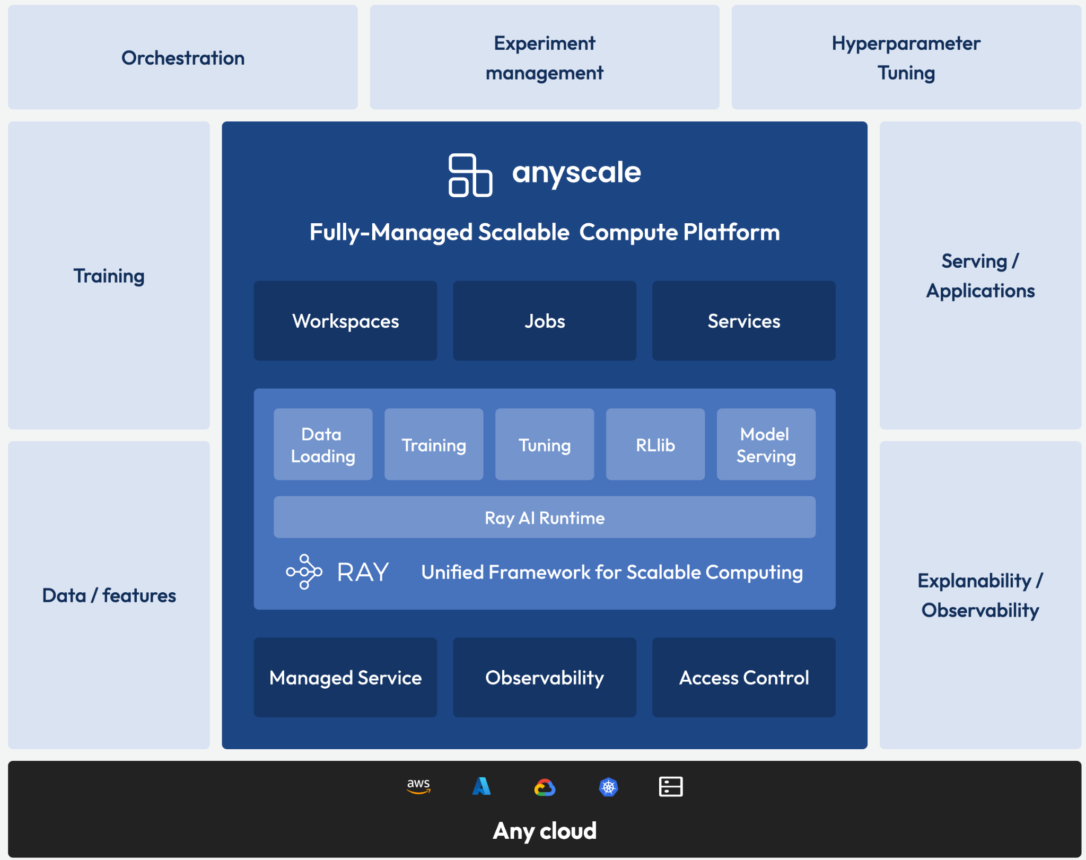

ML Workspace
Anyscale ML Workspace enables users to develop and scale ML applications from prototype to production and back for debugging. This experience makes moving AI applications and ML pipelines to production easier and reduces context switching. It also eases deployments by integrating with best-in-class ML tools like Weights & Biases and Arize AI.

Production Jobs & Services
Whether it’s executing a production workflow on a schedule or running a highly scalable, low-latency production service, Anyscale makes it easy to create, deploy, and monitor machine learning workflows in production.

100% Managed Infrastructure
Let us run Ray for you, hosted on cloud infrastructure fully managed by Anyscale, so that you can focus on what you do best — ship great products.

Observability
Leverage full visibility and ease debugging. Check on the status, health and performance of Ray workloads.

Security and Access Control
Anyscale gives users secure access to secrets managed within the Anyscale environment. All logs and user-relates data is securely managed in a customer's private environment. Secure Network Controls ensure that all communications will take place over private cloud-provider networks. Auditing and logging provide transparency into user access and actions.

- How is Anyscale different from Ray (OSS)?
Anyscale is built around commercialization of Ray. Ray is an open-source distributed computing platform that can be used to scale Python applications with minimal effort. Anyscale will offer an enterprise-grade version of Ray that will include a collection of additional functionality. The idea is to create simpler and easier ways to implement Ray. The product will enable developers of all skill levels to easily build applications that run at any scale, from a laptop to a data center.

Parallels can be drawn here with other successful enterprise software companies which have been built around open-source projects: Apache Spark -> Databricks, Git -> Github, MongoDB open-source -> MongoDB enterprise version, Apache Kafka -> Confluent‎, etc.

